# Chapter 1: Foundation (Sam Altman)

## Why Should You Start a Startup?

* Reality isn’t so glamorous
  + Stressful
  + Always on call
  + Hunched over tables
  + Founder depression
  + 
  + Mark and friends @ FB
* You’ll be the boss?
  + Everyone else is your boss
  + CEOs report to everyone
  + If you want power and authority, **join the army**
* Flexibility?
  + You’ll be able to work any 24 hours a day you want!
* You’ll make more and have more impact?
  + Joining as an employee at mid-early stage growing startup can be worth millions on its own
  + As a founder, you need to be wildly successful for that to make sense
  + Adding a late-stage feature to an established company is a **force multiplier**
    - Employee #1500 at Google made Maps
    - Employee #250 at FB made the like button
* The best reasons for starting a company are:
  + You **need** to do it
  + The world **needs** you to do it
    - The world needs it
    - The world needs you
      * The world needs you somewhere - find where
* Recommended reading list:
  + Hard thing about hard things
  + Zero to one
  + Facebook effect
  + The Tao of leadership
  + The 13 commitments of conscious leadership
  + Nonviolent communication

## Core Principles

*Success = Idea * Product * Team * Execution * Luck (where luck is any number between 0-10000)*

### Idea

#### General Guidelines

* It’s become cool to not spend too much time here and just begin building
* A bad idea is still bad
* Pivots are fine, but most good companies start with a great idea, not a pivot
* Airbnb started because founder couldn’t pay rent
* If this works out, you’re going to be working on this for 10 years
  + So think long and hard if this is something you want
* Plans themselves are worthless, but the act of planning is important
* You need a nice kernel to start with
* You need to build something that’s difficult to replicate
* IDEA FIRST, STARTUP SECOND
* Company should feel like an important **mission**
  + Mission-oriented to get people to rally and be productive around it
  + Hard ideas are easier to garner support for than a derivative easy one
* Your first idea does not need to sound and seem big/visionary

#### Market Size and Growth

* Must think about size, growth of the market, defensibility of the idea
* You **CANNOT** create a market that doesn’t exist
* Monopoly in a large market when you start is impossible
  + Find monopoly in a small market and then quickly expand
  + This is why some great ideas look terrible in the beginning
  + “I know this sounds like a bad idea, but here’s why it’s a **great** one”
* You need a market size that will be big in 10 years
  + Think about what your target market will look like in a decade AND what will cause it to plateau
* How do you tell which markets are growing fastest?
  + Use instincts as a young student

#### Timing

* Why now? Why is this a good time to start this particular company?
  + Why couldn’t it have been done 2 years ago, and why is 2 years in the future too late?

#### Customer Needs

* Best to build something you yourself need
  + Building your first version for a customer who isn’t yourself is hard
* Idea should be easy to explain and understand
  + If takes more than a sentence, it’s too complex
* Try to avoid derivative ideas like:
  + X for red wine lovers
  + Y for dog owners
* Begin with the audience - start with their demands, while you create the supply

### Product

#### Love

* When turning a great idea into a great product:
  + Build something a small number of users **love**
  + **LOVE**. Not like or want a medium amount.
  + Talk to users
  + Eat
  + Sleep
  + Exercise
* Law of conservation of love
  + 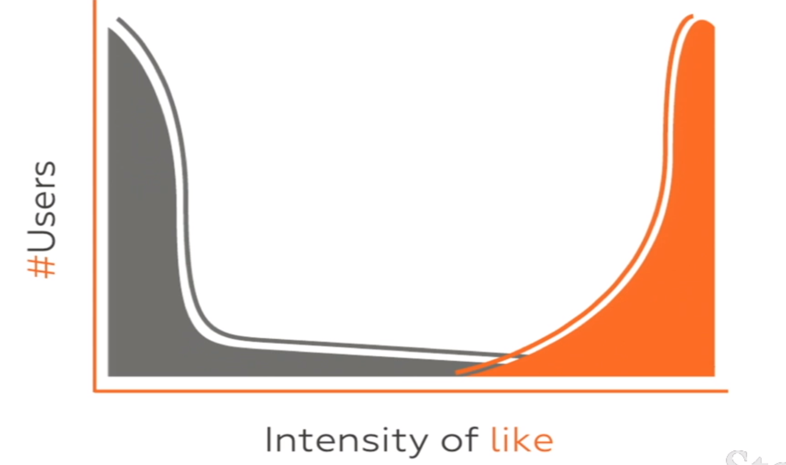
* A key indication of true love is spread by word of mouth (organic growth)
* Best way to achieve this is to start with something simple
  + Even if your eventual plans are complex, begin with as little surface area as possible
* Fanatical commitment to the product helps building great products

#### Learning From Customers

* Recruit initial users by hand
  + Anywhere in the world
  + By any means possible
  + Understand that group extremely well
  + Do anything to make them love you
* Product building feedback loop
  + Make this loop as tight as possible
  + Show product to users
  + What do they like?
  + What would they pay for?  
    What would make them recommend it?
  + Make product decisions

#### Metrics

* Focus on growth
* **Company will build whatever the CEO decides to measure**
  + Active users
  + Activity levels
  + Retention
  + Revenue
  + Net promoter score

### Team

#### Co-founders

* No. 1 cause for death is co-founder blowups
* Most important decision as a startup
* Top 20 YC companies have more than 2 founders
  + Best is tight group of friends with shared history
  + Not good is solo founder
  + Worst is random pairings
* A good model for a co-founder is **James Bond**
  + Relentlessly resourceful
  + Unflappable
  + Creative
  + Decisive
* When should co-founders decide on equity split?
  + Lots of people put this off for way too long
  + Should be done as early as possible
  + If you don't want to give you cofounder even split, think about whether you want this person as a co-founder or not
* How to deal with co-founders leaving?
  + Vesting
    - n/4 of the promised equity where n is number of years worked
* Don’t work remotely with your co-founders

#### Hiring

* Try not to hire
* People tend to judge how real or cool your startup is by your team size
  + It sucks to have lots of employees
  + Low employee count is great
    - Low burn rate
    - Less management
    - Lean, agile
    - Clear direction
* The cost of getting an early hire wrong is VERY HIGH
  + Bad hires can kill the company
  + Airbnb took 5 months to hire their first employee
    - Airbnb CEO came up list of key culture attributes early hires had to have
    - He asked “if u were diagnosed with 1 year left to live, would you work at airbnb?”
    - A bit crazy, but point was made
* Recruiting is **HARD**
  + Great people have lots of great options
  + Long process of convincing that your mission is most important
    - That’s why product is most important
    - People wanna join a rocket ship
* How much time to dedicate to hiring?
  + Either 0% or 25%
  + Biggest block of time spent, or not at all
* How to find the best?
  + Personal referrals build the first 100 people
  + It’s weird to call every great person you met, and ask your team to do the same, but these network effects are most important
  + Look beyond your local community
* Does experience matter?
  + It matters for some roles
    - E.g., someone who runs a large dept or organisation
  + For most early roles, **not really**
    - Go for aptitude
* Things to look for in a hire
  + Are they smart?
  + Do they get things done?
  + Do I want to spend lots of time with them?
  + Do they have good communication skills?
  + What projects have you worked on? (Take a deep, deep dive into this)
  + Are they tolerant to risk?
  + Are they maniacally determined?
  + Animal test
    - You need to be able to describe someone as an animal
    - Ala they need to have a defining characteristic
  + Would you be comfortable reporting to this person if the roles were reversed?
  + **Try to work on a project together instead of an interview**
* Employee equity
  + Aim to give 10% to first 10 employees
  + Be stingy with investors, generous with employees
* Employee retention
  + Praise your team, give them credit
  + Take responsibility for bad stuff
  + Give them increasing responsibility
  + Autonomy + purpose
* Fire fast
  + You want to fire people who
    - Create office politics
    - Persistently negative
  + How to keep existing employees feel secure?
    - Usually fires are constantly making poor decisions
    - Their bad performance is painfully obvious to all

### Execution

#### Jobs of the CEO

* + Set the vision
  + Raise money
  + Evangelise
  + Hire and manage
  + Make sure everyone executes

#### Focus

* + What are you spending time and money on?
  + What are 2 or 3 of the MOST important things?
    - If you cannot distill and act on these things, you will not be effective
  + Say no a lot
  + Set clear overarching goals
  + Communicate
  + Maintain growth and momentum
  + Don’t get distracted
  + Work locally together
  + Intensity
    - Focus and dedication
    - Relentless operating rhythm
    - Obsession with quality
    - Bias towards action, keep moving
    - Do huge things in incremental pieces

#### Momentum and Growth

* Never take your foot off the gas pedal
* Keep accumulating wins
* Software
  + Keep growing
* Hardware
  + Don’t slip up on ship dates
* Save the grand vision speeches for when the company is winning
  + When the company is losing momentum, focus on small wins
  + FB in 2008 setup a growth team that focused on small wins
    - Quickly became the most prestigious group in the company
* Sales fix everything
* Disagreement spawns when startups lose momentum
  + The best way to dissolve disagreement is to **ask users**
* Don’t worry about competitors until they launch a better product
  + **The competitor to be feared is one who never bothers you at all, but goes on making her own business better all the time.d**

# Chapter 2: Before the Startup (Paul Graham)

* Paul’s full essay [here](http://www.paulgraham.com/before.html)

## Counterintuition

* Your instincts do not always work
* Startups are so weird that if you trust your instincts, you’ll make a lot of mistakes
* Listen intently, and do not ignore partners’ advice
  + Counterintuitive ideas contradict intuitions
  + Easy to dismiss advice as something that doesn’t make much sense
  + Only advice that surprises you is worth listening to anyway
* Trust your instincts about people
  + Don’t make the mistake of giving dodgy people a free pass just because this is the ‘business world’
  + Pick partners like you pick friends
  + Good, upstanding folks

## Expertise

* It’s not important to know a lot about startups
* It is most important to be an expert on your users
* Don’t feel bad about not knowing specific mechanics, e.g., fundraising
* One of the key mistakes of young founders is to go through the motions
  + Plausible sounding idea
  + Great valuation
  + Cool office
  + Absolutely fucked
* Never forget to make something people want

## Playing the Game

* Gaming the system stops working
* Mindlessly going through the motions is something you’ve been trained in your entire life
  + Extracurricular activities
  + Artificial standardised tests
* Young founders often want to know what ‘the trick’ is to winning at this new game
* The best formula is:
  + Do well (lol)
  + Grow fast
  + Tell investors
* Gaming the system can work at big companies
* You can even fake your way through investors
* But with startups, you have to stop looking for ‘the trick’
* Different types of work allow for different levels of gaming the system
* How do you win in each type of work?
* What would you like to win by doing?

## All-consuming

* If you start a startup, it will take over your life to a degree you cannot imagine
* And if your startup succeeds, it will take over your life for a long time
  + for several years at the very least, maybe for a decade, maybe for the rest of your working life
  + Opportunity cost is very high
* Every big YC success says the same things:
  + Running a company doesn't get easier
  + Nature of the problems change, but volume of problems is the same
* Starting a startup is like having kids
  + Once you push the button, your life changes irrevocably
  + But people seem to think starting in college is the best thing to do
  + Universities set up entrepreneurship programs left and right because it’s what attracts students
* Starting a startup is something you can only learn by doing it
  + Startups take over you life
  + You cannot be both a student and a startup founder
  + You will be one or the other, or neither
* DO NOT START A STARTUP IN COLLEGE
  + Starting a startup is just a part of a bigger question: how do I live a good life?
  + Startups can be part of a good life for many people, but early 20s is not the time to do it
  + Starting a startup is like a brutally fast depth-first search
  + 20s should be an exploratory breadth-first search
  + You sacrifice nothing if you forgo starting at 20, because you’re more likely to succeed if you wait
  + The usual way for startups to succeed is because founders MAKE THEM succeed
  + It’s stupid to do that at 20

## Trying

* Should you do it at any age?
  + Startups are hard
  + How can you tell if you’re up the challenge?
  + SPOILER: you can’t.
* Paul probably has the most experience at trying to predict if people would be tough and ambitious enough
  + How much can an expert know about this prediction?
  + Not much.
  + Therefore, he keeps an open mind about which startups would be stars
* The only way to know is to try

## Ideas

* So you want to start: what should you do in college?
* Get an idea and some co-founders
  + M.O. for both is the same
  + **The way to get startup ideas is not to try to think of startup ideas**
  + Essay on this topic [here](http://www.paulgraham.com/startupideas.html)
* All the top companies were meant to be companies
  + They were all just side projects
* How do you turn your mind into a startup idea machine?
  + Learn a lot about things that matter
    - Charles: first principles thinking helps here
  + Work on problems that interest you
  + With people you like and respect (this is how you get cofounders)
* Gratifying your interests energetically is the best way to prepare yourself for a startup, and probably the best way to live
* One good way to turn your mind into the type for good startup ideas is to get to the leading edge of a technology
  + Aka “living in the future”
  + At this point, you may not realise your ideas are startup ideas, but you know they ought to exist
* If you want to start a startup after college, learn powerful things
* **Starting a startup is merely an ulterior motive for curiosity: just learn.**

# Chapter 3: Building Product, Talking to Users (Adora Cheung, CEO of Homejoy)

* Have large blocks of uninterrupted time, rather than sporadic, spaced-out
* Describe the problem your idea is solving
  + Verify others have it
* What’s your solution?
  + Become an expert in your space
  + Identify your customer segment and focus on them
  + Storyboard the ideal user experience before you even build
* Build a damn MVP
* Get first users to start trying it
  + Parents
  + Friends
  + Family
  + HN
  + Local communities
  + Reddit
  + Mailing lists
  + Influencers
  + Blog
  + Cold calls/emails
* Now you’ve got users and MVP, get feedback
* Iterate on product
* Ready to ship
  + Just fucking launch it already
* Ready for a lot of users?
  + Learn one channel at a time
  + Iterate on channels that work
  + Revisit failed channels
  + Measure metrics, remain creative
* Types of growth
  + Sticky
    - Returning customers
    - Good experience wins
    - Customer lifetime value and retention are key
    - Repeat (power) users buy more and more over time
  + Viral
    - 1 person tells 5 friends, network effects
    - Great experience + great referral programs
    - Customer touch points
    - Program mechanics
    - Referral conversion
  + Paid
    - Buy growth through ads and marketing
    - Customer lifetime value > customer acquisition cost
    - AKA cost to acquire a user is less than what the customer pays over the course of their subscription/time with you

# Chapter 4: Competition is for Losers (Peter Thiel)

## Capturing Value

* A business creates X dollars of value and captures Y% of X
  + X and Y are independent values
* The US airline industry has more revenue than Google, but its profit margins are less
  + As a result, Google’s market cap is far larger than the airline industry
* Two kinds of businesses in this world
  + Perfectly competitive
  + Monopoly

## Lies People Tell

* Monopolies pretend like they’re in competition
  + We’re in a huge market
  + Example: Google says we’re not a search engine company, we’re an ad company
    - Global ad market is 500 bn, Google is only a fraction of that
    - But in search engines, Google is > 70% dominance
    - But they would never admit that they’re a monopoly
* Competitive companies tell everybody they have a special edge, and are not competing with other companies
  + We’re in a narrow market
  + Example: We’re the only British food in Palo Alto
    - There’s british food in the next town
    - Nobody exclusively eats British food
  + The something of somewhere is usually the nothing of nowhere

## How to Build a Monopoly

* Start small and monopolise
  + Easier to dominate a small market
  + If you think your initial market is too big, it certainly is
  + Too much competition with a big market
* Expand from small markets
  + Amazon started with bookstore
  + eBay started with pez dispensers and beanie babies
  + Paypal started power sellers on ebay
  + FB was 10,000 people at Harvard
* Start big and you’ll shrink
  + Every clean tech company 2005-2008 failed because they tried to take on the whole energy market

## Last Mover Advantage

* Characteristics of a monopoly
  + Proprietary technology
    - Peter Thiel’s thesis is that you should have tech an order of magnitude better than everyone else
  + Network effects
    - Tricky because they’re often to get started
    - Why is it valuable to the first person?
  + Economies of scale
    - High fixed cost, low marginal cost
  + Branding
    - Thiel: I don’t understand it, but it’s important
* Critical to have a monopoly that lasts a long time
  + First movers don’t always win
  + You want to be the last remaining mover
* The value of these companies lasts far into the future
  + Paypal finance exercise in 2001 showed that ¾ of value was cash flow in 2011 and beyond
* Growth rate is overrated, durability is underrated
  + Growth is easy to measure
  + Durability is more qualitative
* Having the first major breakthrough in an industry, and then being able to explain there will not be another one for some time
  + Improving on it at a pace that no one else can keep up
* Chess analogy:
  + White is first mover, gains ⅓ pawn advantage
  + You want to be the last mover, perform the checkmate

## History of Innovation

* In science, it is not uncommon for enormous innovation to go unrewarded
  + In the value equation where a business creates X dollars of value and captures Y% of X, Y has generally been 0 across the board
  + Fundamental delusion where people think our society is fair and just, and they will simply be rewarded for their contribution
* Enormous proportion of history that can be explained from the perspective of captured value
  + Einstein didn’t make much money
  + Railroad companies went bust
  + Wright brothers also went bust
* Only 2 broad industries where people innovated something new and captured value after
  + Complex, **vertically integrated** companies
    - Lots of moving parts, difficult to assemble
    - High value once built and working
    - No single massive breakthrough
    - Massive integration
    - E.g., Tesla, SpaceX, Ford, Standard Oil
  + Software
    - Economies of scale
    - Low marginal cost
    - High adoption rate
* Common rationalisation for scientists who aren’t able to capture value for their innovations
  + “Scientists shouldn’t be motivated by money”
    - This is fair, but this rationalisation is dangerous
    - It means scientists are constantly working in an environment where all the value is competed away, and they’re left with nothing
  + Important to understand that such rationalisation obscures the fact that X and Y are independent variables
  + People of equal intelligence doing equally great things in their specific industries can earn vastly different amounts of money
    - A lot of this has to do with the microeconomics/structure of specific industries

## Psychology of Competition

* We often think losers are the ones who are poor at competing
  + Consider that perhaps competition itself is off
  + We don’t understand competition/monopoly dichotomy properly
  + We find ourselves very attracted to competition, a reassurance that there are other people doing this
* Competition as validation
  + We think lots of people doing something is proof of value
  + PT thinks that is often proof of insanity
  + 20,000/year move to LA to become movie stars
    - 20 make it lol
* School is one such example of senseless competition
  + Does the tournament make sense if you keep going?
  + Does the intensity of competition in grad school make sense?
  + “The battles were so ferocious because the stakes were so small” - Henry Kissinger referring to academia
    - This is also proof of insanity
  + People lose their identities in absurdly competitive environments, they lost sight of what was important
  + Competition does make you better
    - But if often comes at the price of questioning what’s truly important/valuable
    - Don’t get caught up rushing to fit in the tiny door everyone else is trying to get through
    - Go round the corner and take the vast entrance no one noticed
* Risk is a very complicated concept
  + Taking law as a degree sounds like a low-risk path
  + But in the grand view of doing something useful with your life, law may be a pretty high-risk entryway into societal improvement

# Chapter 5: Growth (Alex Schultz, Growth @ FB)

* What matters most for growth?
  + Great product
  + Retention
* How do I measure retention best?
  + Graph of % of active users vs. days since customer acquisition
  + 
  + To get this curve, measure % of active users on 31st day, 32nd day, 33rd day, etc.
    - This will give you an idea of the retention trend for your product
    - Ideally it should flatten out and stabilise at a comfortable level
* What if my retention begins to approach 0? What if it never flattens out and stabilises?
  + **DO NOT HIRE A GROWTH HACKER**
  + Head back to the drawing board, **focus on finding product-market fit**
  + No. 1 problem with new startups is that they do not have product-market fit when they think they do

## Good Retention

* What does good retention look like?
  + Let’s look at some successful companies:
    - Use dimensional reasoning
      * Look at the dimensions involved in a problem
        + Newtons, n/m, m/s, etc.
    - FB’s retention rate is easy to figure out
      * Total no. of internet users (except China) = 2 billion
      * Facebook’s active user count = 1.3 billion
      * Retention rate = 1.3/2 = 65%
    - Whatsapp’s retention
      * MAU / Total smartphone count
  + Successful retention rates look different for different companies
    - Ecommerce: 20-30% is good
    - Social media: < 80% is probably bad

## Scaling

* I have great retention. How do I scale this?
  + This is where growth teams come in
    - If you’re a scrappy startup, don’t have a fucking growth team
    - The whole company should be the growth team
  + The metric (north star) you choose to measure is important
    - Zuckerberg chose active users over total signups
      * It’s not always active users though
    - Whatsapp used messages sent over no. of users
    - Airbnb used no. of nights booked vs. major hotel chains
    - Ebay used total gross merchandise volume instead of revenue
  + Once a company/team grows beyond a certain size, it’s impossible to directly instruct everyone
    - But a north star provides guidance to the fundamental end-goal
    - Affiliate programs are an example of this
      * Paying your affiliates to meet a specific, well-defined goal gets everybody on the same page, and is much more effective
      * At ebay they switched the payment requirement from registered users to ACTIVATED registered users (users who bid on something)
        + Made affiliates focus on driving users to a product instead of driving them to do the bare minimum of registration
        + For ebay users, seeing the desired product and being allowed to bid on it was **the magic moment**

## The Magic Moment

* What’s the magic moment?
  + For Facebook, it was seeing your friends on the platform for the first time
    - That’s why FB growth marketing is all about getting people to connect to their friends as quickly as possible
    - Zuckerberg called in getting to 10 friends in 14 days
  + Airbnb is about finding the the cool house you’ve always wanted
    - For renters, it’s about getting paid for the first time
  + The magic moment is one the of most important things for a startup
    - It lets you move the asymptote of the retention line higher and higher
* Optimising for power vs marginal users
  + When building a product/seeking market fit, optimise for the power user
  + When seeking growth beyond the power user, optimise for marginals

## Tactics

* Users will not beat a path to your door
  + You must work to get users
* Internationalisation is important
  + FB intl’d too late
    - FB clones everywhere in the world
    - Knocking down clones is very difficult
    - Hit a brick wall at 50 million users
    - Growth team was formed
  + Even though they were late, they took the time to build it in a scalable way
    - Wrapped all strings in the site in FPT, FB’s translation engine
    - Opened community translation options for professional+community translators could work on it
    - 70/104 languages were community contributed
    - Language priority was important too
      * Started with French, Italian, German
      * But today these are the lowest no. of users
      * Luckily FPT + community allowed FB languages to scale anyway
    - Negative demonstration: Uber
      * Kicked out of many markets because expansion was too rapid, not localised enough

### Virality

#### PFC

* Think about virality in terms of 3 things
  + Payload
    - How many people can you hit with each blast
  + Frequency
    - How many times can you hit someone per blast
  + Conversion rate
    - % of people who came onboard
* Hotmail added a link to bottom of every email ‘sent with hotmail, get free email here’
  + Payload was low (1 to 1 emails sent)
  + Frequency was high (lots of email sent)
  + CR was high (great product)
* Paypal used ebay as a vehicle for viral marketing
  + Payload was low (1 to 1)
  + Frequency was low (people don’t get paid that often)
  + CR was SUPER high (you got paid! That’s the magic moment!)
* Frequency and conversion rate are related
  + Hitting someone with the same ad again and again lowers conversion rate

#### K-factor

* K-factor = i * (c1 * c2 * c3 * ….)
  + Where i is average number of new persons invited per customer
  + c is % of people who get onboarded at every step
    - E.g., c1 is % of ppl who opened the link
    - C2 is % of ppl who registered
    - C3 is % of people who activated their accounts
* if k-factor > churn, more users come than users leave, and your product is going to have exponential growth
* if k-factor = churn, the virality only compensates the churn, and the number of users will be stable
* if k-factor < churn, the churn of users is not compensated by the virality and audience of the project will gradually decline
* Virality/k-factor fluctuates
  + Use paid channels (adwords, FB) to stabilise growth rate
  + Virality for big wins

### SEO

#### Keywords

* What do people search for?
* How many people search for it?
* How many other companies are ranking for it?
* How valuable is it for you?
* Optimise using Google keyword planner tool

#### Backlinks

* Get valuable links from high authority websites
* Distribute love within your site by internal links
* Internal site directories are great
* XML headers

#### Email

* Delivery is most important, then open/click rate
* Dead for people under 25
* Instant messaging is far more powerful
* Take note what servers your email is being sent on
  + Dirty IPs will send you straight to spam
* Newsletters are stupid
  + The messages for a 3 year veteran user and a newbie are different
  + Notification emails are far more important
    - As a FB veteran, you don’t want to receive emails/SMS for a new like
    - But a newbie or low engagement person would love to know about the likes they get

## A violently executed okay plan today is better than a perfect one tomorrow.

# Chapter 6: How to Build Products Users Love (Kevin Hale)

* Growth is simple
  + Conversion rate vs churn
  + The gap between the two shows how much you will grow
* The motivations to get to a billion dollars are the same as the first dollar
* Kevin built wufoo, a friendly contact form builder
  + Acquired by surveymonkey in 2013
  + Only raised about 100k USD
  + Exited at 35M USD
  + Profit: 29561% (LOL)
  + What did they do differently?
* They were fanatical about creating meaningful relationships with users
  + New users: dating, existing users: marriage
  + First impressions matter
    - * First kiss, how you proposed
      * No free pass if your date picks their nose
      * But married couples shrug that sort of thing off
    - Same with companies
      * Make all your ‘first moments’ memorable
        + First emil
        + Account creation
        + blank/starting interface
        + Login link
        + Ad link
        + First customer support

### Dating (First Impressions)

* Japanese 2 marks of quality
  + Taken-for-granted quality
    - A good pen can write well
  + Enchanting quality
    - The way the pen feels, the way ink flows, etc.
    - The little details matter
    - What’s the user’s first emotion as they interact with this?
    - Little tweaks and quirks of the product make people fall in love
    - 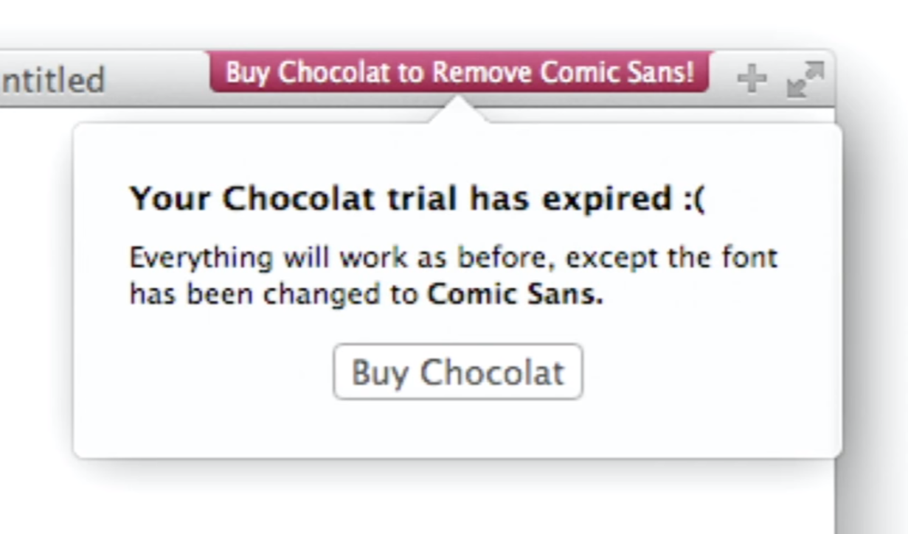
* Companies tend to have beautiful marketing and horrible user guides
  + 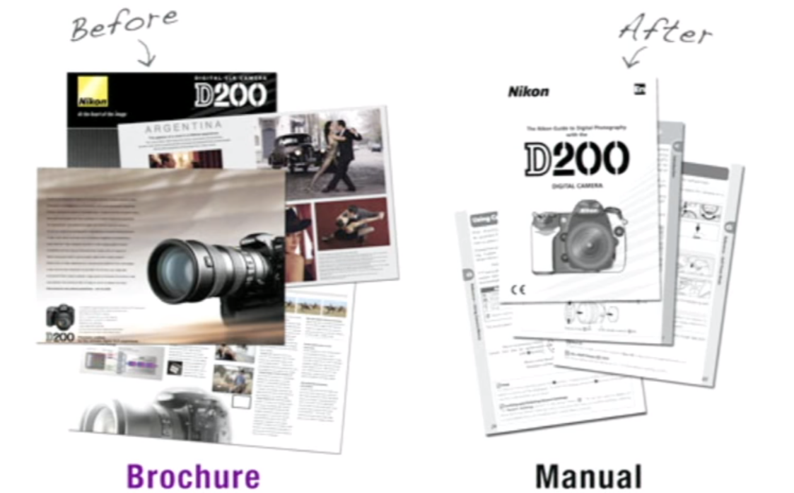
  + Opportunities exist even in seemingly boring avenues for product delight
    - Mailchimp switched user guide document covers to look like magazine covers
      * Readership went up, support calls went down
    - On Stripe, if you’re logged in, the API example code already has your API keys filled in
    - When Wufoo wanted to launch their API, they didnt do a hackathon
      * They gave out a custom battle axe (lmao)
      * 

### Marriage (Existing Users)

* How do relationships work in the long term?
  + Short term conflicts can indicate long term durability
  + All couples fight and it’s about the same things as companies
  + 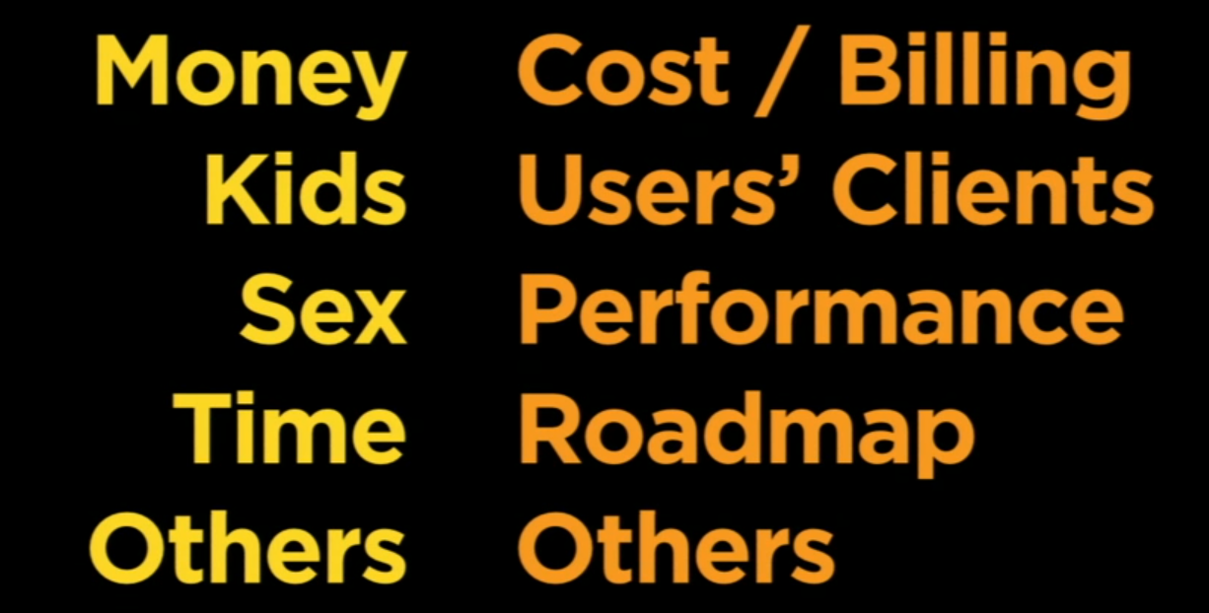
* Engineers/software devs do not often feel the consequences of what they build
  + How do we fix the feedback loop, so even the technical team is accountable for the user experience?

#### Support Driven Development

* Things that screw up relationships
  + Criticism
    - The support sucks, you’re not helpful at all
  + Contempt
    - Purposeful insult
  + Defensiveness
    - Trying not to take responsibility
  + Stonewalling
    - This is the worst
    - Straight up ignoring customer request
* Wufoo built empathy into their support forms with an ‘Emotion’ drop down field
  + This was an optional field, but was filled >75% of the time
  + Indicates that a user **feels** that their emotional state was just as important as their technical details
  + An outlet for emotion allowed users to vent
  + People started being nicer - use of curse/caps/exclamations went down
* Make sure everyone does customer support
  + Responsible devs and designers give the best support
  + Once a dev hears the same problem 2-3 times, it gets fixed
* Everybody in Wufoo did customer support (sometimes with day shift rotations)
  + 500,000 users got support from 10 people
  + Support time was about 7-12 minutes during working hours

#### Direct Exposure

* More exposure to users produced better software
  + Sharing support duties is a great way to do this
  + Direct exposure every 2 weeks for at least 2 hours is best
* Knowledge gap is the gap between your user’s knowledge level and the minimum required to use your app
  + You either educate the user well
  + Or lower the barrier of entry
    - Great help/documentation
    - Contextual help pages
    - Make the app simpler to get going with
* For Wufoo, Great UX and support meant
  + Support requests grew slowly compared to user count
  + Lower churn rate
  + New user increased
  + Team size remain small (this also means everyone gets more equity)
  + Culture maintained

### Relationships Atrophy

* Relationships need work
  + AND you need to show-off that work
  + Newsletter and blogs showing off new features are not very effective
* Wufoo introduced Alerts, which show new updates (work done) when a user logs in after a while
  + Users felt grateful because the team appeared to be working for them all the time
  + 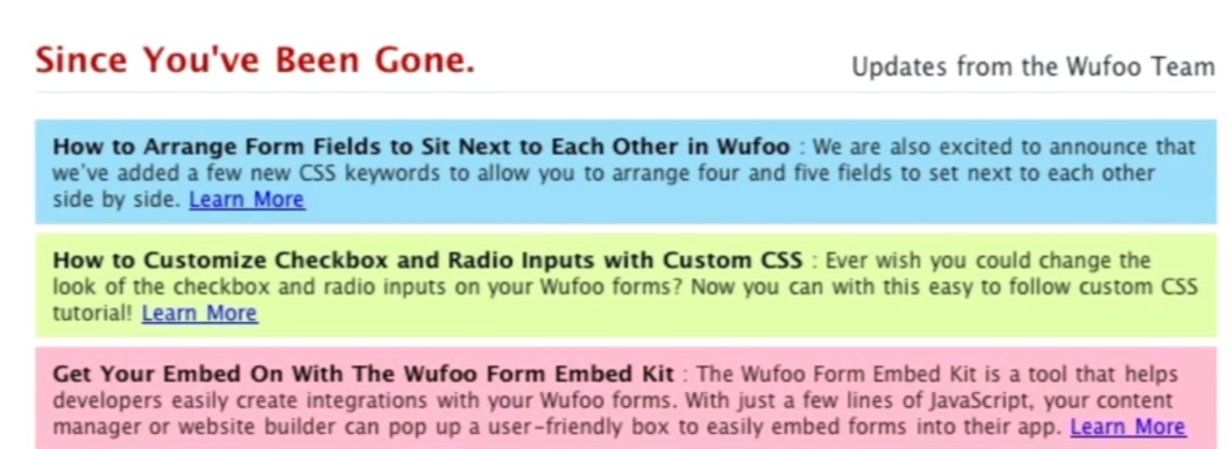
* Every Friday, Wufoo team would write handwritten thank you notes to users
  + Humanises the company
  + Retention is way better

# Chapter 7: How to Get Started, Doing Things that Don't Scale, Press (Stanley Tang @Doordash, Walker Williams @ Teespring, Justin Kan @ Twitch)

## How to Get Started (Stanley)

* Went from idea to website in an hour
* Started paloaltodelivery.com
* Customers streamed in 100% organically
* Only began to scale when demand began becoming crazy
* Keep asking for feedback, do the dirty work yourself for as long as possible
* Only scale when you have to

## Doing Things That Don’t Scale (Walker)

* Initial user acquisition was very painful
* Getting a small non-profit to buy $1000 worth of t-shirts was a lot of work
* Speed is more important than scalability/optimisation in the early days
  + Teespring split codebase into 2 just to accommodate some enterprise customers
  + Smashed code into duplicate just to ship features to enterprise without affecting existing users
  + Slowly integrated new core features into original codebase
* Teespring almost died recently, shrank to 30 employees
  + Victim of its own success
  + The power sellers were doing so well that they found economics of doing t-shirts themselves was better

## Press (Justin)

### Target Audience

* Press should have a target audience and goals
  + If you don’t have a clear business goal/audience, garnering press is a waste of time
    - Investors
    - Customers
    - Industry

### The Story

* You need a good story
  + Types of stories:
    - Product launches
    - Fundraising
    - Milestones
    - Business overviews
    - Stunts
    - Hiring announcements
    - Contributed articles
  + Think about your story objectively - not everything you do is interesting
  + You don’t always have to be original - just original enough
* Mechanics of a story
  + Think of a story
  + Get introduced
  + Set a date (4-7 days in advance)
  + Reach out (get a commitment to invest in time)
  + Pitch
  + Follow up
  + Launch your news!

### Launching

* Ask an entrepreneur who was recently featured by them for a referral
  + Give a week lead time for this
* Executing the launch
  + Write the story in bullet points
    - Memorise it
    - When you get interviewed, you will tell it like it is written
  + Follow-up
    - Thanks for meeting
    - Videos/photos
    - Here’s our launch date
* PR firms are of limited use
  + They can get contacts
  + Can’t produce stories for you
  + Expensive
* Getting press is a lot of work
  + Make sure it’s worth it
  + Getting press doesn’t mean you’re successful
  + Press is not a scalable user acquisition strategy
* If you decide press is worth it
  + Keep contacts fresh
  + Regular heartbeat of news (consistency is key)
  + Golden rule
    - Pay it forward. Always.
    - Karma always comes round

## Recommended Reading

* Burned out blogger’s guide to PR <https://www.amazon.com/dp/B00NFAT238>
* Trust Me I’m Lying <https://www.amazon.com/Trust-Me-Lying-Confessions-Manipulator/dp/1591846285>

# Chapter 8: How to Raise Money (Marc Andreessen, Ron Conway, Parker Conrad)

* What do VCs look for?
  + Of all the companies receiving funding every year, only 15 generate 97% of returns
  + Strength instead of lack of weakness
    - If a startup checks all the boxes and shows no weakness, but likewise has no killer strength, they are unlikely to be in the big 15
    - If they are so good in some aspects, and have tolerable flaws in others, still worth investing
  + Have the one compelling statement for your product
    - For the investor to picture the product in their mind
    - Practise this like crazy
  + Be decisive
    - Don’t procrastinate on important decisions
    - Part of building a great team
  + Communication skills and leadership are no. 1
  + Be **so good** they can’t ignore you
    - Willing to tolerate flaws
    - It’s worth more to make your business better than to make your pitch better
  + **YOUR REPUTATION IS YOUR BIGGEST ASSET**
    - That said, you can get a lot done with not a lot of rep
    - But positive rep will serve you well

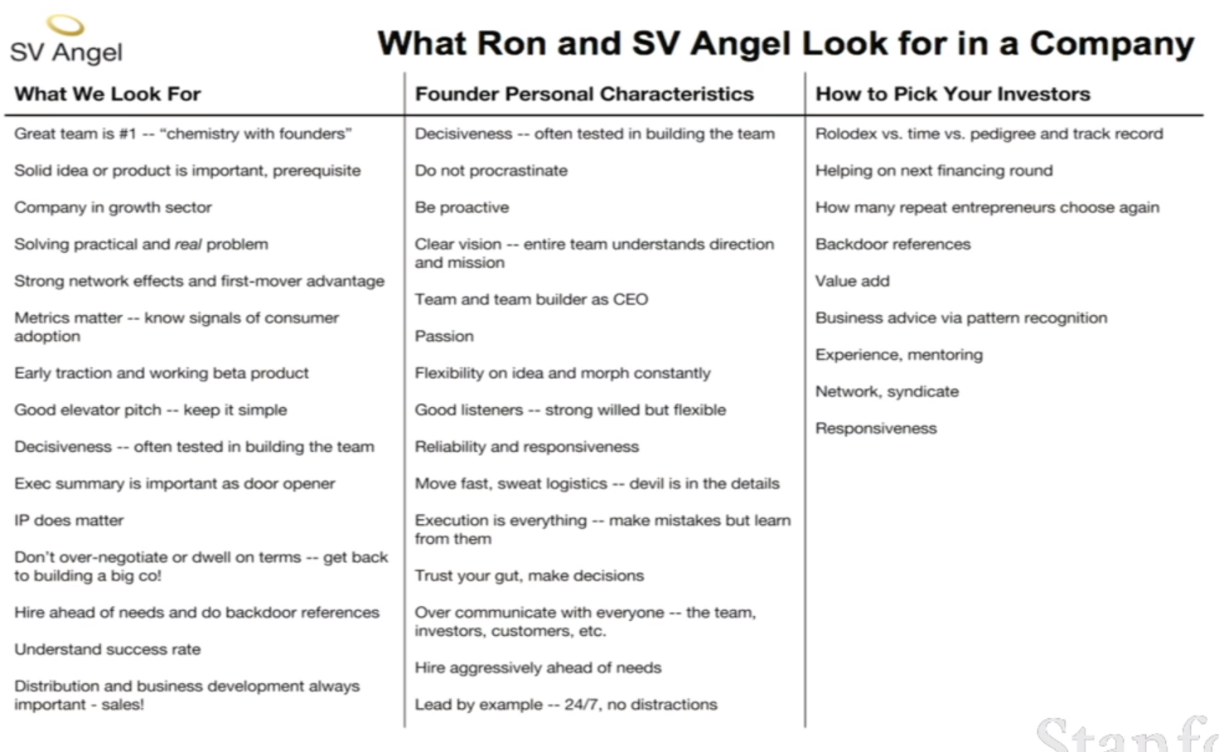

* Bootstrap as long as you possibly can
* Raising venture capital is the easiest thing a startup will ever do
  + If you have a difficult time raising funds, it means that the work you have to do on your startup is going to be 10x harder
    - Recruitment, product, etc.

## The Onion Theory of Risk

* A systematic approach to thinking about how cash gets deployed in risk mitigation
* A new startup has every conceivable kind of risk
  + Founding team risk
  + Product risk
  + Technical risk
  + Launch risk
  + Acceptance risk
  + Revenue risk
  + Cost of sale risk
* Raising money is a tool to peel away layers of risk
  + More money means you can pay your founding team, building product, recruit eng team, etc.
  + Those are the true milestones
  + The money itself is not a milestone
  + Be very clear what milestones you’re attempting to solve with every raise, and fundraising will become much easier and targeted

## General Advice

* Don’t ask someone to sign an NDA
  + Build trust between parties
* ALWAYS get things in writing
  + Do fundraising as quickly and efficiently as possible
  + But always get things on record
  + Take notes
    - When you meet and agree on verbal terms, do up an email, and ask for confirmation on what they just said to you
  + Investors have short memories and commitment
* SV Angel on seed raising
  + Invest in 1 mil to 2 mil rounds
  + 1/30 acceptance rate, about 1 new company a week
  + Team votes if company is worth bringing on for a phone call and then a physical meeting
  + Followed by background checks on company, founding team
  + Following by checks on all other investors in the round
* A16z on series A
  + Most VCs at this stage only look at 2 types of companies
    - Seed raised?
  + Best way to get the attention of series A investors is through referrals from seed investors or places like YC
* What terms should founders care most about?
  + Finding the right investors
    - YC does a good job telling who those people are
  + Picking the right threshold valuations
* How much equity should the company give away during seed?
  + 20-30% at series A
  + 10-15% at seed
  + Founders should ask at what valuation they get demotivated
* What signs should you avoid an investor
  + No domain expertise
  + No rolodex
  + Choosing an investor is like marriage under great stress and anxiety
* What constraints do investors have when bringing companies in?
  + Opportunity cost
    - Every investment made rules out conflicts
    - One investment locks out that category
    - Time and bandwidth of general partners
    - GPs could have done other deals over that time

# Chapter 9: Hiring & Culture (Airbnb, Stripe, Pinterest)

* The most important thing when maintaining company integrity for scaling
* What is company culture?
  + Every A and B of each member of the team in pursuit of our company C
    - A = assumptions, beliefs, **values**
    - B = behaviours, **actions**
    - C = goals, BHAG, **mission**
* Why does this matter?
  + First principles
  + Alignment
  + Stability
  + Trust
  + Exclusion
  + Retention
* How to establish core values
  + What values are most important to you?
  + What are the most important values for business success?
  + What do you look for in employees?
  + What could NEVER be tolerated?
  + Remember to incorporate your mission into your values
* Company values must have depth
  + Honesty, service, teamwork DON’T CUT IT.
* Elements of high performing teams
  + 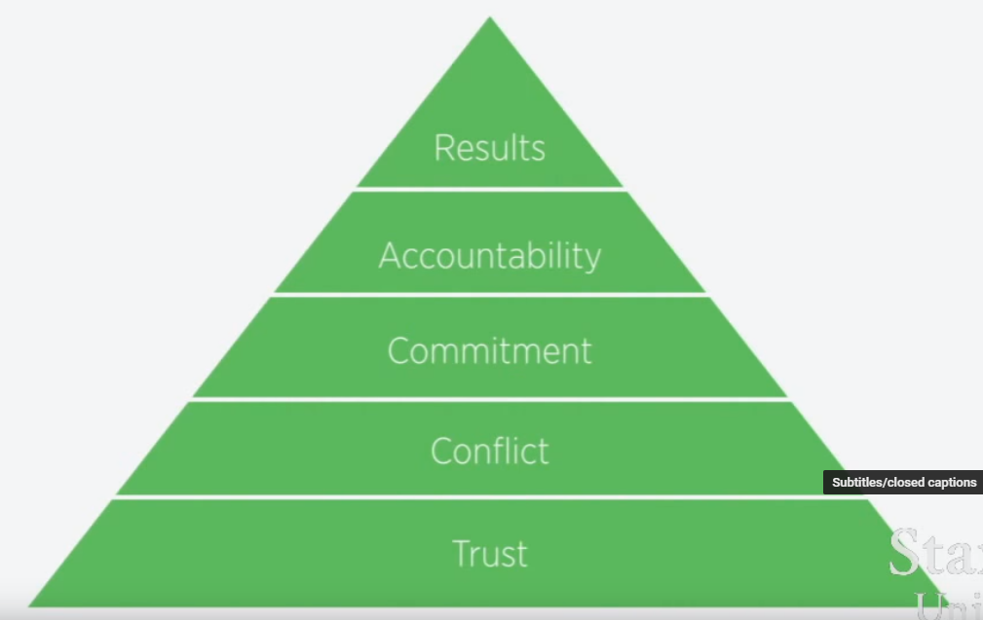
* Best practices for culture
  + Incorporate your mission to your values
  + Think harder and deeper about values
  + Interview from cultural fit
  + Evaluate performance on culture as well
  + Make culture a daily habit

## Q&A with Airbnb

* How did you realise culture was important at Airbnb?
  + I found 2 great teammates who I admired
  + Great shared way of working and doing things
  + Mission was very clear
  + Bringing that mission to the whole company was important
  + Looked at big companies, Apple, Amazon, Nike
  + Even looked at nations
  + All had strong declarations and values to endure the test of time
* What did you learn about Culture from Zappos?
  + 3 or 5 unique values from every other person
  + Wrote down core values before hiring anyone
* Why did you take 3-5 months to hire your first engineer?
  + It was like bringing DNA to the company
  + There would be 1000 more people like him/her that would join the company in the future
  + Diversity of background, age, gender etc.
    - But no diversity of values
* On what basis did you hire
  + All about the mission
  + Not just about putting people in rooms when travelling
  + It’s about bringing people together, so you can belong anywhere
  + “If you had 10 years left to live, would you join this company”
  + Looking for people that are looking for a calling
* Remaining scrappy frugal and creative
  + It’s easy to lose that scrappiness once you’re big
  + Reminder as part of core values to always be creative and not rest on laurels
* How did culture help you make important decisions?
  + Clarity of decision
  + Promise to only hire world-class with cultural fit was natural
  + Rocket Internet attempted to copy and destroy Airbnb with high raise and aggressive hiring
  + The logical thing was for Airbnb to buy them or risk getting destroyed by them
  + Brian felt they were mercenaries just for the money, while Airbnb were missionaries
  + Chose not to buy and maintain integrity with core values
* Culture and brand are two side of the same coin
  + Whatever happens inside the company bleeds into your external image
  + Brand is your connection between you and your customers
  + Strong culture can be a brand in and of itself
  + Apple decided that the way to sell computers wasn’t to talk about bits and bytes
    - It was to talk about values (Think Different Campaign)
    - We believe in these passions and values
    - If you buy our products, you believe in these too
    - Avoid being a utility
* How do you know how to communicate this early in the days?
  + Early on Airbnb pitched itself like a utility
  + Changed to ‘travel like a human’
* How did you make sure the hosts enforce culture of Airbnb?
  + Anybody should be able to use Airbnb
  + Implemented the Superhost program
    - Hitting milestones and providing great service earns superhost status
    - Grants perks, better rates, visibility
  + Organised host conference on reinforcing values
* Open source community?
  + Airbnb thought it could be proprietary technology
  + But they also wanted to keep their tech open
  + Instead they made their defensibility about service
* Be loved instead of liked
  + 100 people loving you is better than 1m liking you
  + The 100 people are your own viral marketing
    - To get these 100, do things that don’t scale
    - Airbnb went out manually photographing everybody’s homes for a better experience

## Q&A with Stripe and Pinterest

* What are the most important pieces of culture in your compmanies
  + Pinterest
    - Hires
    - What do we do everyday
    - What we choose to communicate
    - What we choose celebrate
  + Stripe
    - Transparency internally
    - If everyone is aligned at a high level, and everyone has good access to info and current state of stripe, big step towards working productively
    - Culture is a resolution of a bandwidth problem
      * You can’t make decisions for hundreds of employees
      * Culture allows you to spread strands into getting all employees being aligned
* What did you look for when hiring the first 10 to get culture right?
  + Pinterest
    - Who do I want to work with, and I find talented
    - It’s not architecture, it’s gardening
      * Planting seeds and removing weeds and letting the garden grow
    - Worked hard, high integrity, low ego
    - People with quirks outside of being good engineers
    - Wanting to build something big
  + Stripe
    - Biggest influence on the company
    - Their friends will tell them not to join
    - Had to find people who were undervalued
    - Biggest similarities with first 10
      * Genuine and straightforward
      * Deep into finishing things
      * Cared a great deal (offended when something was off)
    - Takes a long time to recruit people, so getting people around you excited early is important
* How do you tell someone is good?
  + Difficult to discern for categories you don’t have expertise/taste in
    - Must establish what makes someone world-class
    - Ask an already world-class person what defines characteristics in that area
  + Important to be transparent about the vision, why the company is good
    - Lay out the gory details of why it’ll be hard
    - Weeds out candidates
  + Work with the person as much as you can
    - Usually for a week on small project
  + Look for references
    - Important to know what this person was like to work with
* What do you do to make someone effective ASAP?
  + Pinterest
    - When small, it was about setting up their PC, getting them up to speed ASAP
    - Getting to know the person more deeply happened naturally, having spent time together in a scrappy company
    - When bigger, it’s a UX exercise to onboard new people
    - What does the person see, who they meet, what they start by doing
  + Stripe
    - Get them coding/in meetings on the first day
    - Push people off the cliff on the first day
    - Give people feedback on how they’re doing adapting to the culture
* How do you convince people to join you when success is not guaranteed
  + Stripe
    - People often join BECAUSE its not guaranteed
    - Appeal to them on a personal development angle
    - Startups are a great place to benchmark impact and contribution
  + Pinterest
    - No one is under the illusion that you will 100% succeed
    - If they are afraid of this, they’re not as intelligent as you think
* How has your user base affected your hiring strategy?
  + Pinterest
    - Ambition about the mission is most important
    - They don’t need to be lifelong power users
    - If they’re not currently users, it’s good to bring them on so they can remove the barriers they faced
  + Stripe
    - We hired 4 Stripe users early
    - They understood the product right away

# Chapter 10: Building for the Enterprise (Aaron Levie, CEO @ Box)

* Look for underlying environmental factors that are set to change drastically
  + For Box, the price of storage was dropping significantly
* Box fell into the trap of
  + Over-serving consumers (free tier)
    - How do you monetise?
  + Under-serving businesses
    - Insufficient security
    - Enterprise capabilities

## The State of Enterprise

* Enterprise IT market size is several orders of magnitude larger than mobile apps + digital marketing/ads
  + Enterprise is less concerned with dollars and cents vs. improving performance
* Enterprise software was unsexy and slow
  + Building it it slow to prevent customer breakdowns
  + Sales are slow because of long deal-making process
  + No love and care for design and UX
* Enterprise software has changed drastically
  + Cloud computing
    - AWS put together lots of servers available on demand
  + Compute power is cheap
  + Standardisation of enterprise software lets companies go after small startups and giant MNCs
  + Easy internationalisation
  + User-led instead of IT department dictated
* 2 billion mobile phones and growing
* 3 billion users online and growing
* Examples of spaces suited to new innovation
  + Multi-channel retail experiences
    - Online, mobile, physical, delivery
  + Personalised healthcare
  + Media creation and distribution

## How do you get started?

* Spot technology disruptions
  + Look for new enabling tech that creates a gap between **how things have been done and can be done**
  + What has a drop in price/complexity of technology allowed you to do now that didn’t work 5 years ago?
  + EXAMPLE: PlanGrid realised construction industry was printing $4b worth of blueprints, and decided to augment that with cloud and mobile
* Intentionally start small
  + Find a natural wedge - simple and small. A gap in current solutions that a customer would want a discrete solution for
  + Expand over time
  + If people call it a toy, you’re onto something
  + EXAMPLE: Gusto, SaaS for payroll. Now moved into HR, benefits, etc.
* Find asymmetries
  + Do things that incumbents won’t do because they are not economically/technically feasible
  + Be platform agnostic compared to incumbents who can’t adapt to all competitor software
  + Monetize customers from a unique perspective that would be too expensive or too small for a big company to pursue
  + EXAMPLE: Zenefits HR software targeting benefits for small businesses. Earns money from insurance commissions
* Find almost-crazy outliers
  + Live in the future, and figure out what’s missing
  + EXAMPLE: Skycatch does enterprise data collection with drones
* Listen to customers
  + But don’t build what they tell you - distill their requests into what they **need**
  + EXAMPLE: Palantir takes in unclear customer data requests, distills into key valuable insights
* Be modular, not customised
  + Don’t customise and be bespoke to each company
  + Difficult to maintain
  + Think about pluggable modules instead
  + EXAMPLE: SalesForce
* Focus on the user
  + Keep consumer DNA at the core of your product
  + Makes adoption easier
* Product should sell itself
  + Sales is important to navigate and close deals, but a great product is still key

# Chapter 11: How to be a Great Founder (Reid Hoffman @ LinkedIn)

* Founders are often seen as superwoman/man
  + Many skills, abilities, element of divinity
* Truth is that founders have to deal with a multiple of headaches
  + One hopes to have a few unique skills
  + Competitive edge is important

## Questions for Founders

* How do I put together a founding team?
  + Best to be on a team of 2 to 3
    - Solo is not ideal
    - Compensate for weaknesses
    - Tackle diversity of problems
* Where should I locate my startup?
  + Seek the networks that best fit your endeavour
  + Groupon wouldn’t have worked in SV
    - SV people are adverse to massive sales forces
* Should I be contrarian?
  + Find something that smart people disagree with you on
  + What do I know that other people don’t?
  + Critics said LinkedIn wouldn’t work because of the vast amount of network effects needed to get going
  + LinkedIn knew that he could leverage different sets of interests to get people on board to try the product in a short span of time
* When should I do the work vs. delegation?
  + Sometimes one, the other, or both
* Should I be flexible or persistent?
  + When should I be either?
  + You should have an investment thesis to decide this
    - Why you think this is a good idea
    - What you think you know but other people don’t
    - Are you increasing in confidence for your investment thesis?
    - If decreasing, find out what is causing the decrease, and form an immediate action plan
* Should I be confident or cautious
  + Confidence in your own ideas, but be smart enough to listen to sharp feedback, criticism, competitive entries
  + Is this changing my investment thesis?
  + How do I adapt?
* Should I focus internally or externally?
* Should I work by vision or data?
  + Data only exists within the framework of a larger vision
  + Measure what you need to move towards a vision
* Should I take risks or minimise risks?
  + Taking calculated risk is part of business
  + But minimising risk within that framework is one of your most important jobs
  + Aka optimising chances of success
  + Start with the thesis
    - Is every step we take increasing or decreasing confidence in the thesis?
* Should I focus on long or short term?
  + Daily/weekly todo lists have to play towards a larger path
* How do I know I’m a great founder?
  + Helps to be a great product person
  + Leadership at bringing networks and persuasion
  + Recognising macro view if you’re on track
    - Paranoia vs. confidence
* There is no single skill set
  + Ability to continuously learn and adapt
  + Take in input from multiple sources
  + Creating networks around you

## Q&A with Reid Hoffman

* How did you target the early adopters that would strengthen LinkedIn
  + Our strategy won’t work today
  + Too much noise today
  + Strategy today has to be standing out from the crowd
* How do you know someone’s a good founder?
  + I believe in references the most
  + Insight into someone before they show up is often the best way
* The ability to say coherently what you’re targeting - a focused sentence - is important
  + Level of clarity and articulation is key to being a good founder
* How did LinkedIn remain persistent throughout hard times?
  + Kept returning back to thesis of wanting professional profiles for everyone
  + No one is getting closer to it than they were
* What are the ways of being fooled into thinking a founder is good when they’re actually rubbish?
  + I like to push on someone’s idea, and see if they’re able to remain flexible and persistent on it
    - “I stand by this idea, but i’m listening to what you’re saying”
* What makes a great co-founder team, how to evaluate?
  + Collaborate really well, do they help each other get to truth?
  + Collective learning makes great teams
  + Do you have diversity of strengths across the skills that are useful
* Different founders, different areas, how do you identify them?
  + What’s common across all great ounders?
    - Software needs speed
    - Hardware needs accuracy
  + Domain-specific founders
    - Attributes that are unique to domain
    - E.g., operational efficiency and cost control is important for commerce
    - for digital game startups like Zynga is not as important
* When should you stay when something is taking longer than it should? (When to pivot)
  + Confidence in investment thesis
    - Unmeasured or decreasing for a long time
    - Intense phase to try and increase confidence
    - Increasing fails
    - Time to pivot
  + Founders have no balance
    - Intense, lopsided focus for periods of time are necessary
* Creating markets vs. discovering them?
  + Creating a market is usually either completely worthless or a big opportunity
    - What about my investment thesis can tell me whether this is a good opportunity or not?
* How do you know you trust someone enough to be a cofounder
  + It’s a risk
  + Establishing at least 20 hours of conversation and time spent together
  + What would tell me this isn’t working?
    - Hash this out and converse about it

# Chapter 12: How to Operate (Keith Rabois, Khosla, Square)

* Building companies is harder than products
* Company building starts from a lovingly drawn-out plan
  + Plan when put into practice is never as clean, held together by people working 100 hours a week
  + Eventually one wants to build a high performance engine, able to operate without much oversight
  + “If martians took over ebay, no one would notice for quite a while”
* A manager’s output = output organisation + output neighbouring organisation
* Triaging
  + Company begins in mess and chaos
  + If there aren’t new problems and challenges everyday, it means you’re not innovating or creating fast enough
  + The idea here is that you’re triaging
  + Discerning colds from pneumonia, figuring out where priorities for problem solving lie
* Editing
  + Simplify and eliminate
    - The more you simplify, the better your team will perform
    - Easily understood > complexity
  + GOAL: reduce amount of corrections/interjections needed to keep team on track
    - It’s okay to need to make lots of corrections on a bad day
    - But this should reduce month to month, quarter to quarter as the company gets tighter
* Clarify
  + Ask a lot of question to seek clarification
  + Clarifying makes sure the problem statement is clear, everyone is on same page
  + Improves overall performance
* Allocate resources
  + Moving your resources around to favour the landscape
  + Initiatives to new resource allocation can come top down
  + But ideally they should come bottom up
  + Employees seek initiative to do new and useful things, which you then approve as an editor
* Ensure consistent voice
  + Make sure all external/internal media sounds like it was written by one person
  + Keep the tone of the company consistent
  + Apple is one of the best at this
* Delegate
  + Abdicate vs micromanagement
  + You do not do most of the work, but you are responsible for all of it
  + How to manage without abdicating?
    - Task-relevant maturity framework
    - If someone has low maturity, needs more hand-holding
    - If someone has done this a lot, monitor and set high objectives
  + A leader cannot have a **single** management style
    - Style is dictated by employee, and matters what make that employee most effective
  + How to decide when to delegate or take control?
  + 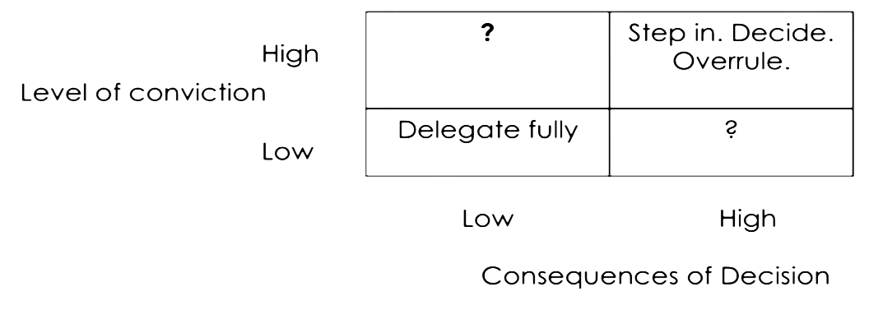
* Edit the Team
  + Increasing worker count is not always the best way to increase work done
  + Barrel analogy
    - Most people (even great employees) are ammunition
    - More ammunition is great, but rate of fire is limited by number of barrels (people who channel and increase throughput)
    - Velocity of company increases when you have more barrels and stock them with ammunition
* Scaling
  + 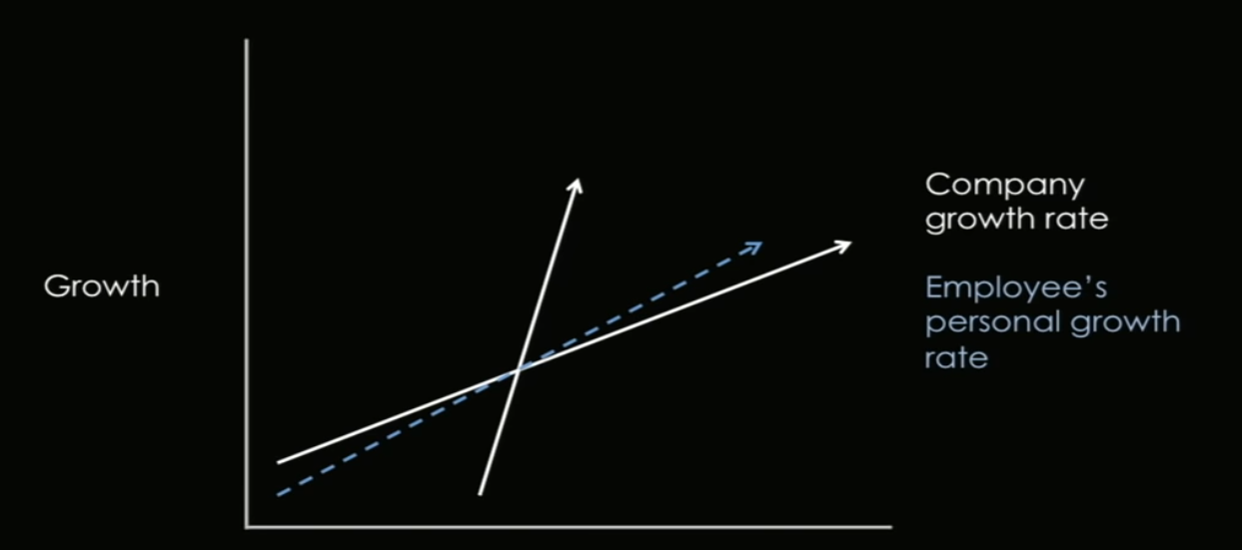
  + Note employee personal growth rates vs company growth rates
  + Only keep employees who can keep pace with the company
  + If employees can outpace the company - good! Keep them in new roles constantly
* Insist on Focus
  + Keep employees focused on some very key roles, don’t stretch them thin
* Metrics & Transparency
  + In order for you to not to have to make all the decisions, provide tools so that everybody can see and make decision for themselves
    - Build an internal dashboard that tracks metrics that are in line with company goals
    - Monitor usage of the dashboard - make sure it’s intuitive, useful and empowering
  + Make sure all meeting notes and metrics are available to everyone in the company
  + Compensation should be open as well
  + Gathering information by pairing indicators: measure effect and counter effects
    - Release criteria vs ship date
    - Number of hires vs quality of hires
    - Loss rate vs false positives
* Building positive work environment + insisting every part of the company meets standards
  + Ensuring receptionist answers the phone properly
  + Serving good food
  + Working on small things - taking distractions away from employees is one of the key roles for a COO
* Effort
  + Lead by example

# Chapter 13: How to Manage (Ben Horowitz)

* When making a critical decision, you must understand how it will be interpreted from each person’s point of view, and their perspective as a whole (culture)

## Demote or Fire?

* Executive is great, works hard, well-liked, but not world-class at running his function
  + CEO thinks
    - Tough to fire a great employee
    - Demotion is good cus you can keep him
    - No cultural backlash
  + Exec thinks
    - Doesn’t want demotion, but provides an option
    - Saves embarrassment of getting fired
    - Able to keep growing with the company
  + Everyone else thinks
    - Does he keep the same equity package?
    - Is he gonna work as hard now that he reports to someone else?
    - Do I have the same respect now that he’s demoted?
* The real questions here are:
  + What does it mean to fail on your job?
  + What does it mean to maintain your equity?

## Excellent Employee Asks for Raise

* CEO thinks
  + Want to retain them
  + They did great job, it’s fair
  + They will like you if you give them the raise and you want to be liked
* Employee thinks
  + WOOHOO MONEY
* Everybody Else
  + Unfair that I didn’t get a raise
  + I did better work, so doubly unfair
  + Maybe I should quit
* Conclusion
  + Everybody feels a responsibility to ask for a raise personally
  + Encouraging behaviour
* Right answer
  + Formal performance evaluation process
  + All the right inputs
  + Run evaluations as frequently as possible
  + No raises outside of the process

## History’s Greatest Practitioner

### Toussaint L’Overture

* Born an african slave
* Wanted to end slavery, take control of Haiti, make it first class
* Soldier’s perspective
  + Do we get to pillage? We enjoy pillaging
  + If they get to kill us, we should get to kill them
* Culture
  + He banned rape and pillaging in his army to protect the resultant culture
  + Toussaint wanted a first-class culture
  + He believed Haitian culture was inferior to European, and slave culture the worst of all
    - Whenever he defeated a European power, he would capture and make their leaders his generals

### Dealing with Slaves and Slave Owners After Victory

* Slave perspectives
  + Free us, we fought for this
  + Kill the owners
  + Give us their land
* Toussaint perspective
  + Economy is important, and productive plantation are important
  + We’re mostly slaves
  + We don’t have the expertise to run sugar plantations
  + We earned that land
* Slave owner perspective
  + Our business is predicated on slave labour
  + We paid a lot of money for the slaves
  + We paid for the land
  + We have all the skill and relationships, so you have to deal business with us
* Solution
  + End slavery
  + Let the slave owners keep land
  + Require plantation owners to pay salaries to workers
  + Lower the plantation owner taxes so they can keep business going
* Result
  + Only successful slave revolution
  + Let plantation owners keep land
  + Booming economy
  + Under Toussaint, Haiti had more export income than USA
* Conclusion
  + Seek perspectives of the people not in the room
  + Think of the company
  + Think of the culture

# Chapter 14: Great User Interviews (Emmett Shear @ Twitch)

## Twitch Story

* Started with Kiko Calendar which was built without talking to any users - did not even use calendars themselves
* Then built Justin.tv which they used themselves, so they could get away with not talking to other users
* Could not figure out how to scale justin.tv beyond their narrow use case
* Pivoted to Twitch, at which point they had to learn about video game broadcasting
* Determined that broadcasters were the most important users
* Gathered feedback from existing broadcasters on Twitch.tv
  + Feedback was consistent, clear, led clear feature requests
  + People wanted small features like banlists, removal of trolls, polls
  + Emmett argues if they are willing to put up with these problems and still use the platform, these problems are not the highest priority
* Instead, gathered feedback from broadcasters on competitor platforms
  + Feedback was completely different
  + People wanted revenue sharing, better video service, stability
* Gathered feedback from non-broadcasters who want to broadcast
  + **This is the most important, as they are the people you want to bring on to expand the size of the market**
  + Feedback was different again
  + People say PCs aren’t fast enough, not enough time because training, publishing strategy online was bad for competitive teams
  + Led to the team trying to make broadcasting more accessible
    - Building Twitch into Xbox, PS4,

## Conducting the Interviews

* Who you talk to is as important as the questions you ask
* Where do you go to find target users?
* Initial questionnaires should not focus on specific user flows or features
  + These are distractions
* Listen out for big blockers - is there something inherently wrong with the way people feel about it?
* Identify one key feature that puts your new product one level above the competition
* Next ask yourself - is it worth it? Is this worth building into a product?
* Validation can happen 2 ways
  + Actually build it (if you’re good at code)
  + Draw out diagrams/work flow and show it to people
    - Don’t fall into the trap of asking ‘is this feature good or not?’
      * People will usually say its gr8
    - Can get them to pay for it up front - money where your mouth is

## Q&A

* What are the most common mistakes?
  + Don’t show people your product. It’s like telling them the feature to look at
  + Talk to people you need to, not the people you have access to
* How hard is it to get buy-in from the rest of the company to build something?
  + Record and show your team the interviews
* Do you insist on Skype interviews or email?
  + Avoid email interviews, as the best parts of the an interview usually come from questions outside of the script
* What about reaching people in intl market to do interviews?
  + Twitch admittedly still works best in english speaking countries
  + Tried to solve this by hiring Korean speaking folks, translators, etc.
* What channels did you use to reach out and did you compensate?
  + On-site messaging systems
  + Events
  + No compensation
* What about on-site user feedback on the product?
  + It’s great for testing a product pre-launch
  + It doesn’t tell you what to build next
* What makes good user feedback?
  + Want to learn about what user is really thinking
  + Problems, get to know them as a person
  + Don’t colour their opinions with your influence

# Chapter 15: How to Design Hardware Products (Hosain Rahman @ Jawbone)

* Started straight out of school
* Developed core technology, built products around that
* Started with headset that became a wearable computer
* Kick-started wireless audio space around bluetooth
* Focus should shift away from vast system of internet of things
  + Focus on the users - personal wearables
* To do this, you need to be great at the full stack
  + Hardware
  + Software
  + Services
  + Data
* All these verticals require different skills and disciplines
  + Initial merge of hardware and software created friction within the company
  + Software used to moving fast, hardware iterations slow
  + Hardware team needed to learn to move fast, software team learnt to focus on experience before shipping

## Product Development Flow

* How does Jawbone create?

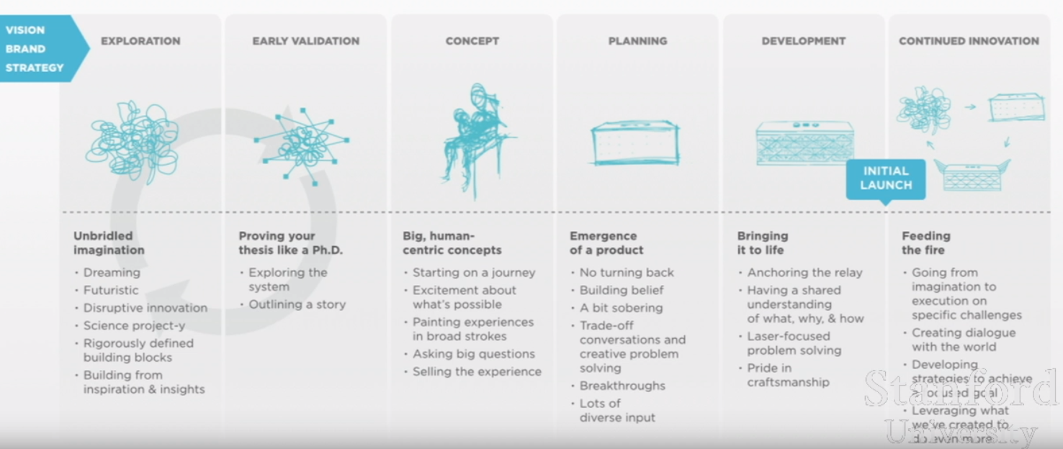

* Exploration
  + Building and tinkering
  + Demo Fridays, show and tell
  + Hackathon, using data and insights to think big
  + Unbridled imagination
  + R&D team leads this charge, but everyone is free to join in
  + Executives act as a sounding board to provide guidance
  + **REQUIREMENT TO MOVE INTO NEXT PHASE**
    - Would CTO put $50k into this project to ‘angel invest’ in them?
* Early validation
  + Checking for robustness of concept
  + Meetings with development managers
  + Use scientific method
    - Feasibility
    - Data and insights
    - Hypotheses
    - “Hero experiences”
  + R&D team lead, different depts help with feasibility studies, business cases, user interviews
  + Executives prioritise emerging concepts and approve budget
  + **REQUIREMENT TO MOVE INTO NEXT PHASE**
    - Fits into our strategic vision
    - Is it technically feasible to make now
    - Business viability
* Concept
  + Defining the Whys and features
  + Use tools like
    - Storyboards
    - Interaction models
    - User research
    - Hero experience
    - Pitch videos
    - Data and insights
  + Lead by product experience team
    - Supported by hardware/software engineers for feasibility and problem solving
    - Also by product management team for business use cases
  + Executive team helps imagination/ideation process, determine if idea has legs
  + **REQUIREMENT TO MOVE INTO NEXT PHASE**
    - Highly resolved whys
    - Clear differentiation strategy from competitors, other company products
    - Product road map
* Planning
  + Making business plan
  + Building story
  + Quarterly forecasting
  + Retail calendar
  + AOP
  + Tools used
    - Early prototypes
    - Feasibility documents
    - Functional, inspirational briefs
    - Data and insights
  + Lead by product management team
    - Supported by all other depts
    - Sales and marketing team set timeline
    - Finance team lays out capital and forecast
  + Executive team decides trade-offs and signs off on plan
  + **REQUIREMENT TO MOVE INTO NEXT PHASE**
    - Prioritised features
    - Minimum functionality bar
    - Business plan and product roadmap
* Development
  + Continuation of planning phase
  + **REQUIREMENT TO MOVE INTO NEXT PHASE**
    - Design sign-off
    - Engineering sign-off
    - CEO sign-off
* Continued innovation (post-launch)
  + How to deepen and broaden engagement
  + Continue to increase value for users
  + New ways to tell stories
  + Driven by retail calendar, sprint cycles
  + Tools used
    - Feature briefs
    - UI screenshots
    - Marcomm briefs
    - Data and insights
  + Lead by product management team
  + Executive team provides guidance on goals and strategies
    - Also approves only Jawbone-standard output

## The Experience Framework

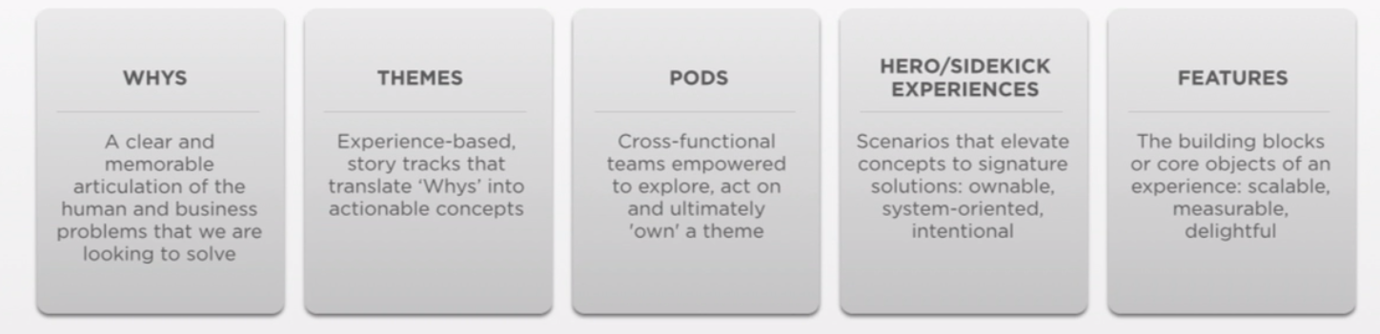

* Whys
  + What is the core user problem?
  + That once we solve, users can’t live without?
    - For Jawbone, the introduction of a $199 speaker for your mobile phone was unthinkable to a regular user or focus group
    - But once released, it dominated 78% of the market
* EXAMPLE: Audio experience
  + My content isn’t as mobile as it could be
    - It’s all concentrated on my mobile
  + The content should be seamless across time and space
  + For Jawbone, speakers were the way to get into homes and become the hub of service and software
* Experience Continuum
  + How to flow users into a ‘future world’
  + Allows thinking about feature trade-offs
    - If we can’t add feature to current gen, users will be ready for it when next gen comes
  + TODAY
    - Beautiful portable speakers that seamlessly sync music content
  + TOMORROW
    - Introduce occasion-based listening experiences that reinforce portability, extensibility, social engagement through hardware, software, services
  + FUTURE
    - Full ecosystem of aware, autonomous products
    - Adapt to user’s environment, habits, audio sources
* It’s all about creating experiences, not just hardware

## The Whys of Up24 (Minimalist fitness tracker)

* Real-time feedback to track and achieve goals today, rather than try to do better tomorrow
* Understand my data in a more meaningful, timely way to make the value obvious
* I need guidance and structure on motivating activities to keep me going
* I want ongoing encouragement and validation
* I want a fluid/frictionless way to log activities, to never ‘miss’ a sleep

## Q&A

* How do you communicate or check for trade-offs across the company when you’re focusing on one vertical?
  + When you start small it's easy
  + When big, you have to force communication
  + Everyone has to share their pains so you can balance priorities across different silos
  + Always refer to the original vision board of the product
  + Does the product still meet those requirements?
* If a startup wants to build an ecosystem, where to start?
  + Almost everything we build is a system
  + Even the standalone app is a system
  + Still about trade-offs between verticals to get the best product
* How to decide when to expand?
  + Some of it is planned
  + NA > Europe > Asia
  + Some of it is opportunistic
    - Great partner
    - Strong cultural fit
    - Partnership with Apple store
  + Manufacturing took place in China
    - Gradually had their own Chinese team on the ground
* Do you run Jawbone like a hardware or software company?
  + Merging both is difficult
  + We’re not following any example model
    - Likely not been done in this way before
  + Trying to merge different disciplines is both fun and painful
    - Need to cherry pick the best parts of both disciplines and come up with their own model of what works

# Chapter 16: Legal and Accounting for Startups (Kirsty Nathoo, Carolynn Levy)

* Boring but necessary to know the broad picture
* Will save a lot of pain, money

## Formation

* Keep it simple
* Form a separate legal entity to prevent personal liability
* Delaware is the best place to form corporations
  + Standardised, clear, familiar
* How do you set that up?
  + Fax paperwork to Delaware
  + Sets up a shell company
  + Everybody must have titles for CEO, president, secretary, etc.
  + Be clear about the split between you and company as separate identities
* Can use law firms and online services
  + YC uses **Clerky** to incorporate
* **Keep signed documents in a safe place**
  + If big funding round, acquisition, THIS IS SUPER IMPORTANT

## Equity Allocation

* How to divide the pie?
  + Ideas alone are worth nothing
  + Execution is worth most of all
  + Should probably be split equal among co founders
    - Disproportionate split is a red flag
    - Are founders not revealing any bad blood/ill feelings?
    - Honesty about expectations for the future
  + Look forward, not backwards
    - Is everyone in it for the long haul?
    - Everyone should be in it 100%
    - Doesn’t matter about who did code, education, idea, etc.
    - If moving forward, everyone is 100% committed, an even split is natural
* Even as a founder, you must attain your shares from the company (a separate entity) through a **stock purchase agreement**
  + Two-way transaction
  + Usually in the form of cash/stock payments over time in exchange for IP, code, inventions that the company now owns
  + This stock is referred to as being restricted
    - It vests over time
* Restricted stock involves a VERY VERY important document
  + **83b election** affects individual and company taxes
  + Not doing this document properly can blow up deals
  + Keep **proof-of-submission** or investors may walk away if the paperwork disappears

## Vesting

* Earning the personal ownership of the shares over time
  + If you leave before the vesting period is over, the company will get unvested shares back
* What should a typical vesting period be?
  + Standard in SV is 4 years with a 1 year cliff
  + After 1 year, the founder owns 25% of his shares
  + The remainder vest monthly over the next 3 years
* What happens when a founder leaves before vesting period is over?
  + If founder leaves before a year, they get nothing
  + If they leave after a year, company repurchases the remaining 75% at whatever share price the founder paid for it
* Why would you have vesting?
  + Keeps founders committed to the company
* Should solo founders have vesting?
  + Yes, skin in the game still applies
  + If an investor is brought in, they will also have vesting
  + Not fair that the founder has no vesting then
* Vesting sets the tone for the company - everyone is in this for the long haul

## Fundraising

* Two ways to raise money
  + Priced or non-priced rounds
* Seed round = price not set
* Series X round = price set
* **Non-priced** rounds is the fastest way to get done
  + Conducting through convertible notes or safes
  + Basically a smart contract which dictates the amount of shares an investor receives at the end of a **priced** round
  + Basically this investor is not yet a shareholder, and will have fundamentally different rights
* Investors at such an early round want something in return
  + That’s where the **valuation cap** comes in
  + For a seed round, an investor might come in at $100,000 at a 5 mil cap = 2% of the company
  + At a later priced round, where the valuation of the company is set at 20 mil, original investor gets 20/5 = 4 times as many shares as a new investor at that round
* Can use Clerky again for fundraising docs
* Future dilution is something that founders must think about before giving away shares willy nilly
* Investors must be sophisticated
  + Must have enough money to invest
  + They must understand that startups is a risky investment
  + “Accredited investors”
  + Investors who want money back later is a problem

## Investor Terminology

* Board seat
  + Sometimes investors will ask for a seat on the board
  + Most of the time you want to say no
  + Be very sure the investor is someone who brings a lot of value to the table
  + If someone can help with strategy and direction for real, that’s priceless
* Advisors
  + So many people want to give advice, but few give good stuff
  + All investors should be advisors by default, with no additional returns
  + If they’re already invested in the company, they should want it to do well
  + Asking for more shares/money is a red flag
* Pro rata rights
  + The right to maintain your % ownership by buying more shares in the company in the future
  + Allows one to prevent dilution on their own shares in the company
  + A common request from investors, not necessarily a bad thing
  + As a founder, you MUST know how this works
  + Key insight: for an investor to maintain pro-rata right, it means the founders likely have to suffer more dilution
* Information rights
  + Investors want rights to know information about your company
  + Periodic updates to investors is a good thing
  + Avenue to ask for help from investors on hiring, advice, etc.
  + But be careful when investors demand things like monthly budget reports, weekly updates, not okay

## Expenses

* Business expenses
  + Cost of carrying out business
    - Hosting
    - Rent
    - Salaries
  + Important for logging on company tax returns
    - Reduces tax that company pays
  + Non-business expenses incurred by the company actually increase the taxes the company has to pay
* Investors gave a lot of money, and they want to see that money make the co succeed
  + Make sure what you spend on business expenses are indeed for the business
  + Difficult to separate this in the early stages, when your office is your house, etc.
* Bookkeeping is important
  + Keep all your receipts
  + When you eventually engage a bookkeeper, all these receipts are important

## Wages and Firing

* Founder Employment
  + Founders are employees of the company and must be paid wages
  + Minimum wage is advised
* Companies must pay payroll taxes
  + Setting up payroll service is worth spending money on
  + Companies have blew up by avoiding payroll taxes
* Founder Breakups
  + Paying all founders is important
  + If one founder leaves, he/she may use a lack of wages as leverage to get more money for leaving
  + This is typically in the form of vesting acceleration
  + AVOID THIS AT ALL COSTS

## Hiring Employees

* Is the new hire an employee or contractor?
  + Both sign documents that assign IP they create to the company
  + Contractors set their own hours
    - Given a clear project and end result
    - Use their own equipment
    - No say in day-to-day dealings
    - Taxes are the responsibility of the individual
    - Company will give 1099 document to the contractor which they will use for personal tax returns
  + Employee
    - Companies responsible for taxes
    - Receives a W2 form for personal tax returns
    - Need to be paid minimum wage
    - Workers Compensation Insurance is important to prevent fines
    - Proof of work in the USA
* You must use a payroll service provider to handle complex payroll for you
  + Zenpayroll is one good service

## Firing Employees

* Firing is hard
  + Requires a founder to do what is right, not what is easy
* Fire fast
  + Do not put off the difficult conversation
  + Don’t let the bad employee linger
  + May make good employees quit
* Communicate effectively
  + Make clear direct statements
  + Don’t make excuses
  + Don’t apologise
  + Face to face with a third party present
* Pay all wages and accrue vacation
* Cut-off access to digital systems ASAP
* Repurchase unvested stock

## Biggest Takeaways

* Keep it simple, organised
* Be fair and forward-looking about equity ownership. VEST
* Stock doesn’t buy itself
* Be savvy about financing documents
* Founders must get paid
* Employees must sign docs to assign IP to company
* Fire quickly and professionally
* Know your key metrics
  + Cash position, burn rate, runway
* Follow the rules and take it seriously

## Q&A

* How to search for accountant and when?
  + Bookkeeper vs. CPA/accountant
    - Bookkeepers handle receipts and expenses
    - CPA handles ANNUAL tax returns
  + Probably okay for founders in the early days to do this themselves
  + But best to engage a service like indinero to handle this
    - Not worth a founder’s time to figure this shit out
  + Look for CPA/bookkeeper/lawyers via reference
    - Make sure they specialise in startups
* What about fees and legal council?
  + Incorporation can be done for cheap online, without a lawyer
  + Use Clerky to handle most standardised fundraising/incorporation things
* What about crypto & equity?
  + Banks will struggle to deal with this
  + No general advice, it’s product specific

# Chapter 17: Sales and Marketing; How to Talk to Investors (Tyler Bosmeny @ Clever, YC Partners)

* People think about building a great product first, and then hiring the sales people after
* Truth is that the salesperson is YOU
  + Build or sell - nothing else matters
  + Pick a founder to own this completely
  + Founder passion trumps sales experience

## The Sales Funnel

### Prospecting

* Who will even take your call?
  + Find the innovators (<2.5%)
  + It’s a game of probabilities
  + Reach out to >100 companies
  + Top 3 methods
    - Network
    - Conferences
      * Small, niche places
      * Set up meetings beforehand
      * Email all attendees
    - Cold emails
      * Simple, straight to the point
      * Who are you
      * What are you doing
      * Why should I be interested
      * CTA
    - 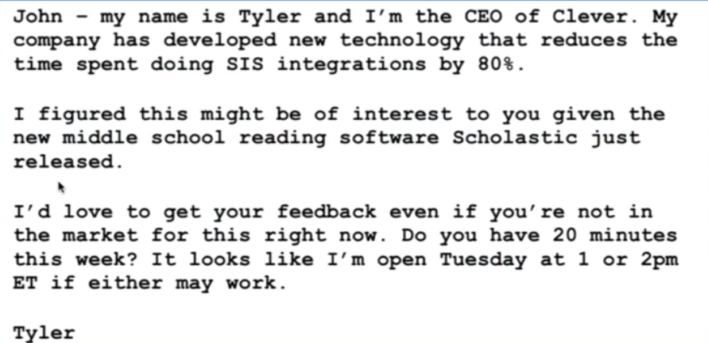

### Conversations

* Now that you’re on the phone:
  + TALK LESS
  + Let the customer speak (70%)
  + Ask good questions to understand their problem?
    - Why did you agree to take my call?
    - How do you currently solve this problem?
    - What would your ideal solution look like?
* Follow-up religiously
  + Even with perfect customers, there will be many no-replies
  + Especially with high-profile busy customers
  + Drive things to closure in an inhuman, unreasonable way
* Get people to a yes or no as quickly as you can

### Closing

* YC has standard agreement templates
* Remember your goals
  + Get customers
  + Get validation
  + Get revenue
* Common traps
  + Redlining
    - Don’t quibble over minor points
    - Keep your ego out of the way
  + 1 more feature
    - Sometimes customers will say, ‘I’d use your product, but it’s missing one feature’
    - First reaction is to promise to build that feature for them
    - But the reality is that companies will rarely follow up on that promise
    - Avoid building one thing for one customer
    - Either:
      * Sign a conditional agreement in writing
      * Or wait to hear more demand from more customers (if this is really worth building)
  + Free trials
    - This is a reasonable request, BUT
    - Early on, you need revenue, commitment and validation
    - People will usually flake out
    - Offer an annual contract with a cancellation period after delivery

### Revenue

* 5 ways to build a big business
  + 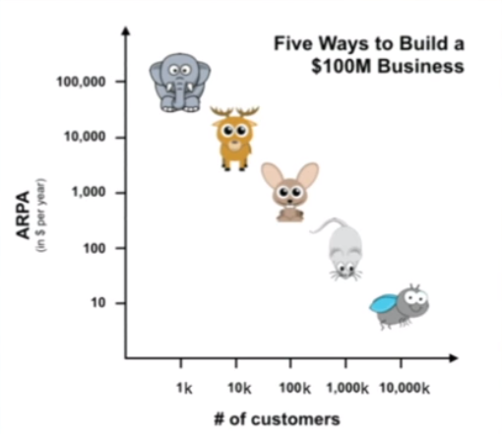
  + Flea/mice/rabbits rely on marketing
  + Deer rely on inside sales
  + Elephants rely on field sales
* Price your product carefully to fall into the category that you want
  + If you’re a rabbit and charge 1000/year, flying out to see that customer for demos, setup, presentations will NOT BE WORTH IT
* [tyler@clever.com](mailto:tyler@clever.com)

## Talking to Investors

* The best way to make your pitch better is to make your company better

### Before Meeting

* How to pitch?
  + 30 second pitch
    - What does your company do?
      * Assume audience knows nothing
      * One sentence mom test, simple language
    - How big is the market?
      * Do some research, not difficult to get
    - How much traction do you have?
      * ‘We launched in Jan, growing 30% month on month”
      * If no customers, convince investor that you’re working quickly
      * ‘Started work in Jan, beta in March, launch by next month’
  + 2 minute pitch
    - 30s pitch
    - Unique insight
      * Opportunity to tell audience something they didn’t know
      * Something the big players don’t understand
      * Aha moment! Watch for this expression
      * Crystallise to 2 sentences
    - How you make money
      * Business model
      * One sentence long, make sure it’s clear and stand by it
    - Team
      * If someone has done something impressive, call that out
      * Don’t ramble on awards, phds, whatever
      * Focus on how many founders, how many technical, how many business, how long have you known each other
      * Everyone working full-time
      * How you met
    - ASK FOR MONEY
      * Convertible note? Safe? What’s the cap?
      * How much are you asking for?
      * Minimum check size
* When to fundraise?
  + Investors like traction
  + Unfortunately, you will be in a situation where you won’t have much traction
    - SInce you’re the one asking for money, they are strong, you are weak
    - How do you flip the equation?
    - You want a situation where investors WANT to give you money
      * You are strong, they are weak
      * Good time to start fundraising
  + To create a situation where people want to fund you, you need to:
  + Spread the word
    - Press
    - Friends
  + Plan such that you don’t need much funds to grow
    - 95% of startups can bring product to market with very little money
    - Take the mindset of, “we’re all on this train that’s leaving the station. If you wanna invest, great. If not, we have other options”
  + Always be able to show you have a committed team that’s working fast
* How to setup investor meetings
  + Warm intros are best
    - Previous founders
    - Referrals from other investors are so-so
  + Think in parallel
    - Fundraising is a sprint
    - Line up all your meetings in a single week
    - “Hey we’re in build mode for the next 2 weeks. Can we do a meeting 3 weeks from now?”
      * Gives you buffer time to line everyone up then
      * Hints that you’re not desperate - we’re busy
  + Fundraising should be something one person takes charge of
    - Don’t distract the whole company

### During Meeting

* Bad Example
  + Make sure the listener understands what you’re talking about
  + Know your numbers
  + Tell your market-size through a bottom-up analysis - don’t just name drop big companies
  + Understand something that is counter-intuitive
  + Team should be uniquely suited to this business
  + Drive the conversation to a conclusion
* Good Example
  + Capture interest, told an interesting story, engage with listener
  + Demonstrate insights and command of the market with passion, not intellectual dismissiveness
  + Collaborative meeting - not a 1-1 interview
  + Asked for money with details and such
  + Drove to a close
    - We’re closing the round, these are our other backers, etc.

### After Meeting

* Follow up!
  + Anything other than check is a no
* Work on creating demand (supply/demand)
  + Say that there are other people in the round
  + “Mike is willing to fill up the round, but we want to bring you on”
* Do diligence on the investors
  + Be very careful who you’re selling to
* Know when to stop fundraising
  + Don’t get addicted to it
* Build your company properly (fundraising is not the goal)

# Chapter 18: Later-Stage Advice (Sam Altman)

* Catered for months 12-24
* After product-market fit
* Waste of time until you have something working

## Management

* Establish structure
  + Needed at about 25 employees
  + Every employee should have a manager, every manager should know their reports
  + Know how to change structure, add new people
* Management structure
  + Avoid fancy new management structures
  + Keep it lightweight and straightforward
* Shifting from building a GREAT PRODUCT to GREAT COMPANY
* Failure cases
  + Being afraid to hire senior people is a big mistake
    - They bring experience and insight
    - Don’t hire too early
  + Hero Mode
    - Extreme leading by example is unsustainable
    - Don’t stay in this until you burnout
  + Bad Delegation
    - Not giving enough responsibility
    - WRONG: “Here’s this big thing. Research and get back to me. I’ll decide, then you go and implement it”
    - CORRECT: “You’re really smart, and I trust you. There’s this thing we need to do, and you can make the decision on whether to do this or not. Let me know what you decide”
  + Not developing a personal tracking and productivity system
    - Keep track of what everybody is doing in as systematic way
* Codify **how** you do things and **why** you do things
  + Cultural values and strategy
  + Put it down in a wiki
  + If you don’t do this, other people will get their own impressions from unverified sources

## HR

* Once set-up, can speed you up
  + Have clear structure
    - Clear path
    - How can I advance my careers
  + Performance feedback loop
    - Speed and frequency
    - Simple
    - Make it clear how feedback loops tie to compensation and penalising
  + Compensation tied to performance
  + Equity - be generous
    - Investors will give bad advice
    - Distribute 3-5% per year
    - According to YC data, the best companies give out to employees well
* Stock and Vesting
  + Refresher grants
    - Don’t wait for people to just wait around to let their stock vest
    - Be ahead of the curve, offer them refreshed vest plans
  + New structures
    - 6 years
    - Pyramid vesting
    - Continuous forward vesting
  + Use a good option management system
* 50 employee requirements
  + Sexual harassment policy
  + Diversity training
* Monitor for burnout
  + You don’t want people to work in product mode all the time
  + You want them to take vacations and try new things
* Hiring process
  + Full-time recruiters
    - Don’t bring on too early, bring on when you need high volume
  + Internal announcements
    - Send new incoming offers to the whole company (up till a reasonable size)
    - Oftentimes people will know the incoming person, and can call out if a bad hire
  + Ramp-up new hires
    - What does the first week look like?
    - Buddy system?
  + Diversity on the team
    - Start this early
    - Don’t let your first 20 be all dudes, or you institute a culture which is difficult to fix
  + Growth of early employees
    - Scenario where an early employee wants a role, but she just doesn’t suit it. Company has evolved past an early employee. How do you deal with them?
    - Be proactive about it, think ahead when company is still small
    - Talk to them, find out what they want, chart out a clear path for them

## Company Productivity

* Alignment
  + No. 1 reason companies drop in productivity is when not everyone is on same page
  + Or worse, work against each other
  + More than half the battle
* Clear roadmap and goals
  + Everyone knows the roadmap for next 3-6 months
  + All employees can say the same top 3 goals
* Figure out values early
* Be run by product, not process
  + Some process/framework is necessary for product dev, but don’t let it be the main driver
  + Ship everyday
    - Continued focus on delivery
* Have transparency and rhythm in communication
  + Weekly management meetings
  + All-hands meetings
  + Quarterly/annual planning
  + Offsites

## 